Response to reviewers and associate editor

We have carefully considered all of the comments for our paper. We appreciate the insightfulness of the reviewers and associate editor, and have made changes according to the reviews. These changes are highlighted in red in the revised manuscript. In addition, direct responses to the reviews can be found below; text from the review is in bold, and our response is in indented, unbolded text.

In addition to the changes we made in response to the review, we have also made one other major change. We have changed the phrase “sequential path planning” to “sequential *trajectory* planning” to emphasize that our proposed algorithms produce a continuous sequence of states over time, as opposed to just a geometric curve in space. We believe that this change is necessary to accurately describe our approach.

# Associate Editor Comments

**- The authors should probably reference the work of LaValle and that of Pallottino as they seem to be related to the subject of the paper. I would suggest:**

**LaValle, S. M., & Hutchinson, S. A. (1998). Optimal motion planning for multiple robots having independent goals. IEEE Transactions on Robotics and Automation, 14(6), 912-925.**

**Pallottino, L., Scordio, V. G., Bicchi, A., & Frazzoli, E. (2007). Decentralized cooperative policy for conflict resolution in multivehicle systems. IEEE Transactions on Robotics, 23(6), 1170-1183.**

**But there are several other papers by the authors that may be relevant.**

We have incorporated these great reference suggestions into our introduction, as well as added a few recent references on multi-agent analysis.

**By imposing a total order on the vehicles, the authors give up completeness. They should be clear about this in the paper and they should discuss why such a trade-ff is worthwhile. Note that saying that the problem is too difficult to solve otherwise is not a good reason. The authors should convince the reader that there are realistic scenarios where such an approach is well justified. Further, as Reviewer 1 observes, there should be some discussion on how the ordering can be chosen.**

Our algorithm does not necessarily give up completeness, as in the trajectory planning problem statement, the initial time (called latest departure time) is a free variable that can always be found. This point is addressed in later comments in this response.

The ordering can be chosen in a first-come-first-serve basis by, for example, an air navigation service provider, as discussed in Reference [2]. Here, different agencies and companies can request air space-time, which is assigned in order of the time of request, or even in a batch with the ordering within the batch decided by the service provider. Although the deciding on an ordering is out of the scope of our paper, a brief discussion of this point is added in Section I-A and end of Section II.

**- The authors should report the computational times for the simulations. Are the authors claiming that their approach can be used online? If yes, the simulations should convince the reader that is feasible. If not, the authors should explain how exactly will their approach benefit applications. In fact, the paper would be much stronger if the approach was demonstrated on real UAVs.**

Almost all the computation is done offline, and involves computing the value functions associated with reachable sets. The gradient of the value function is stored as a look-up table, and accessed online in real-time to synthesize the controller through, for example, equations (13) or (19). For control-affine systems with bounded control, the optimal controls have an analytic form. We have clarified this point in Sections I-A and II. We have also added computation times in Sections IV-B, V-B, and VI-B.

We fully agree that hardware experiments would strengthen this paper, and are currently working on implementing our work in our quadrotor testbed.

**- The authors claim that the algorithm scales linearly with the number of vehicles (with no intruder). However, it would appear that the number of obstacles is also important. As the complexity of obstacles (constraints) is on average n/2 for each vehicle, the computational complexity may actually grow quadratically. A discussion in the paper may be in order.**

The algorithm indeed scales linearly with the number of vehicles (with no intruder). This is because we are using a single function in Equation (9) to capture all obstacles to be avoided by vehicle ; in implementation, this would be a single look-up table. For trajectory planning for the next vehicle , can simply be updated by adding an additional term to the union in Equation (9).

It is true that Step 4 of algorithm 1 involves computing for all , which makes the complexity technically quadratic. However, this computation simply involves storing in a space that contains all vehicles – if the state spaces of the vehicles are at most 4 dimensional in , then is a 4D look-up table – and then updated recursively via . Then, during trajectory planning, vehicle would simply ignore any irrelevant dimensions of .

We have clarified this point at the end of Section IV-A.

**Reviewer 2 suggests that it may be worthwhile directly comparing the approach with a more recent work in the literature on multi-agent systems.**

Please see responses below.

**Finally, Reviewer 3 suggests how to improve the literature review and the bibliography. The reviewer also asks for a more extensive simulation and challenges the second assumption in Section VI.**

Please see responses below.

# Reviewer: 1. Comments to the Author

**The paper introduces scalable path planning for multi-vehicle systems based on Hamilton-Jacobi reachability computation. The goal of each vehicle is to reach its target location on time while avoiding collisions. The main idea of the proposed solution is to linearly order the vehicles and perform the planning sequentially, always considering the plans of the previous vehicles as time-varying obstacles. Several cases are discussed: First, it is planning without disturbances and with perfect information. Second, it is planning with disturbances and three different control methods that are associated with different information sharing among the vehicles: centralized control, where a certain control strategy is enforced; least restrictive control, where the control strategy is only assumed to ensure arriving to the target location on time; and robust trajectory tracking, where a nominal trajectory is tracked with an error bound. Third, planning in presence of disturbances and an intruder is discussed with the assumptions that the intruder leaves the system after a certain duration and that the intruder’s dynamics is known.**

**The considered problem is timely and strongly motivated, especially in the context of recent advances in the use of UAVs. The main idea is in fact very simple, but that is in my opinion what makes it elegant and applicable. It might be interesting though to include a discussion on how the ordering of the vehicles is determined and how it influences the outcome, i.e. the latest departure times of the vehicles. For instance, in the numerical simulations, the chosen ordering is in accordance with the growing scheduled time of arrival. Is it a coincidence or is there a particular reason for that?**

As mentioned in a response to an earlier comment, ordering may be determined through a first-come-first-serve basis by, for example, an air navigation service provider. One may imagine that different agencies and companies would request a flight plan consisting of reserved space-time. A request made for vehicle by some agency or company would be responded by computing the nominal trajectories and space-time needed for this vehicle. A brief discussion of this point is added to the Section I-A and end of Section II.

The ordering in numerical example in Section IV-B is chosen to best illustrate the effect of induced obstacles on the growth of backward reachable sets, shown in Fig. 2. The accordance with scheduled time of arrival is just a coincidence.

**The paper is extremely clearly written and organized, allowing readers to first grasp the concept on the most simple setup and guiding them towards solutions for more and more interesting cases. Appropriate numerical simulations supporting the developed theory are included. As far as I am concerned, the presented technical material is correct.**

**Minor comments:**

**- I would appreciate a little bit more details and intuitive explanations on time-varying reachability background.**

We have added more details around the reachability theory as well as the time-varying reachability. We have also added a tutorial reference for an in-depth explanation of some of these tools. Here is a relevant snapshot from the revised version:

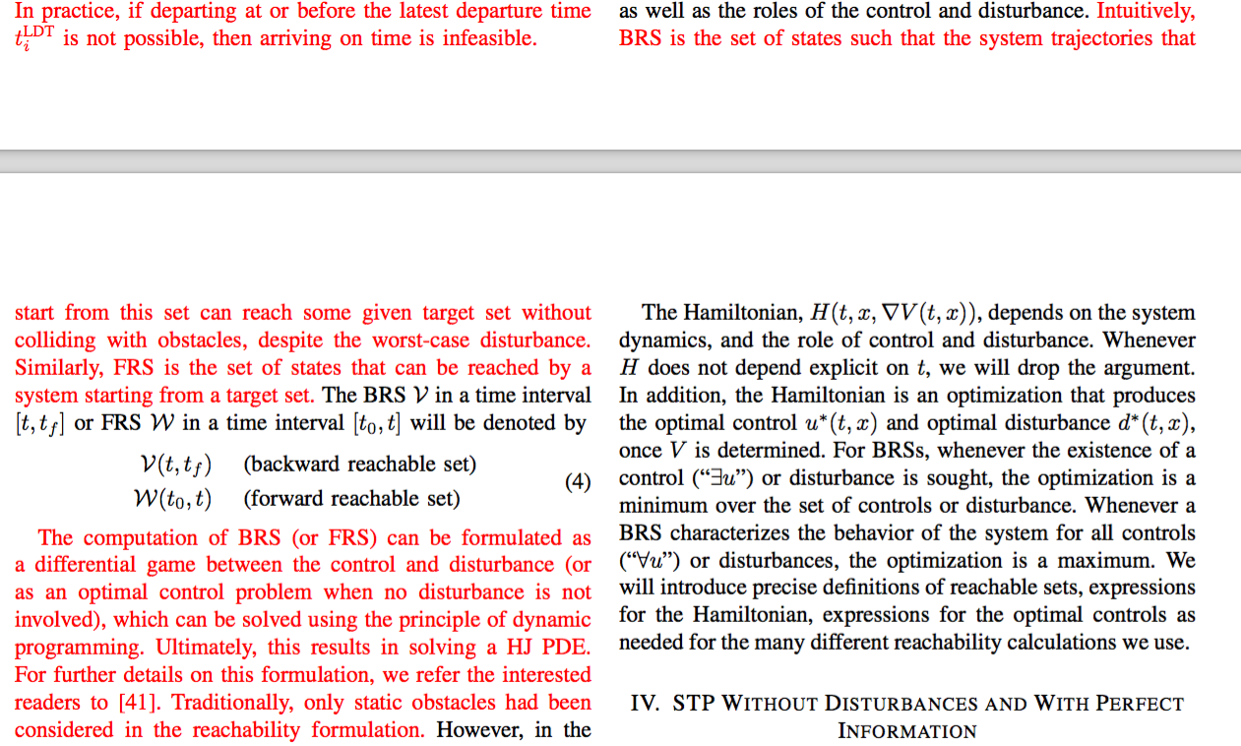

**- Beginning of Sec. IV: “… SPP algorithm can still serve as a useful approximation in certain situations”: It might be helpful to give a concrete example here.**

We agree that the above statement was confusing. We have edited it to be clear. Here is the snapshot of the relevant change.

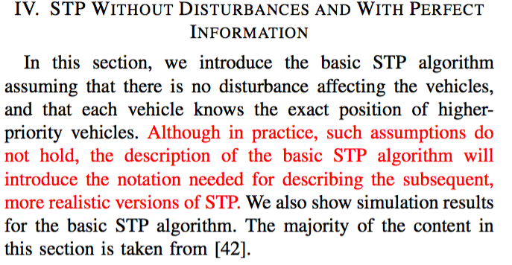

**- “This is precisely the set P_i(t).”: Please clarify.**

Please see the modified text from the paper.

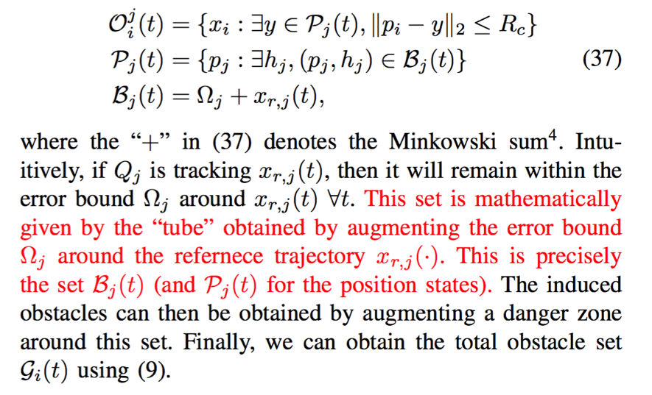

**- It might be helpful to add a discussion on how the reduced control set and the parameter R_EB should be chosen in Sec. V.A.3.**

For the simulations in this paper, the reduced control set and the parameter R_EB were chosen on a trial and error basis. In particular, these parameters were chosen such that the resultant tracking error bound Omega_j is nonempty. However, since then, we have developed a reachability based method to compute the tracking bound Omega_j, which gives us the correct bound irrespective of the R_EB value we start with. More details on this method can be found in the following article:

S. Herbert, M. Chen, S. Han, S. Bansal, J.F. Fisac and C.J. Tomlin, “FaSTrack: a Modular Framework for Fast and Guaranteed Safe Motion Planning,” 56th IEEE Conference on Decision and Control, Dec 2017.

However, developing a principled way to select the reduced control authority remains an interesting future direction. Nevertheless, we have clarified this in the text as the reviewer has suggested.

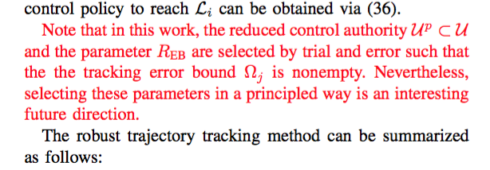

**- It may be interesting to add a clarification of the following questions: In general, avoiding the intruder may cause a vehicle not being able to reach a target region any more, correct? Does the optimal avoidance control from Eq. (55) ensures the target region remains reachable?**

We thank the reviewer for this very insightful comment. It is indeed possible that the re-planning is infeasible depending on the initial state of a vehicle after avoiding the intruder. One potential scenario where this could occur is when the dynamics of the vehicle or disturbances in them are such that the vehicle can’t reach its target destination irrespective of the control applied by it.

However, this remains a challenge for any path planning algorithm. To begin with, it may be possible that the initial condition of the vehicle (i.e., even before the intruder appears) is such that it cannot be guaranteed to safely reach its target. Fortunately, for most practical systems, it should be possible to reach any non-obstructed region of state space, given a long enough time horizon. For the sake of completeness, we have added this comment in the main text:

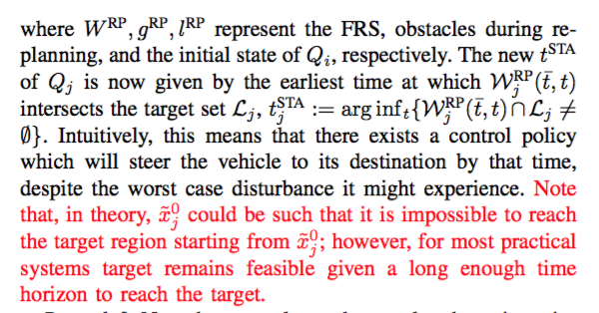

# Reviewer: 2. Comments to the Author

**This paper presents a robust sequential path planning framework to deal with a multi-agent system path planning problem. It considers the disturbances and adversarial intruder which makes the path planning problem more complex. Hamilton-Jacobi is utilized to provide a base of the framework due to the effectiveness facing trajectory planning and avoidance under disturbances. To overcome the computing intractability, sequential method is introduced. Moreover, three methodologies are designed for the disturbances and adversarial intruder. Both simulations and analysis are provided to verify the theory. Some minor comments should be addressed in the revised version.**

**1. In section 3, the backward and forward reachable set are introduced and computed by solving the partially differential equations, i.e., Eq.~(5) and Eq.~(6), in which $D_t$ is not formally given.**

We thank the reviewer for pointing this out. We have now formally defined D_t and other terms in equations (5) and (6). Please see a snapshot of the modified text below.

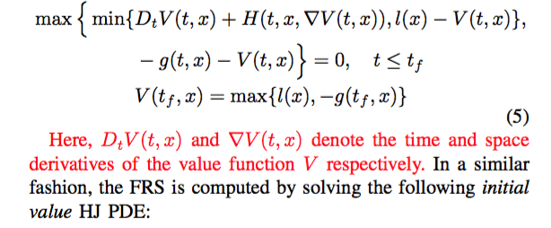

**2. In this paper, authors define the danger zone $Z_{i,j}=\{(x_i,x_j):||p_i-p_j||_2\leq R_c\}$ only based on the position information. In reality applications, there exists a kind of inevitable danger zone, where the robot or UAV will be in danger zone with a hundred percent. It is suggested to provide more details about such inevitable danger zones.**

This is a very good point. This could happen, for example, when the vehicle is very close to obstacles and disturbances are strong enough that there is no way to avoid a collision with another vehicle/obstacle. However, backward reachability, by definition, would never steer the vehicle to such a state (unless the vehicle starts at such a state itself.) In particular, the reachability provides a controller that is guaranteed to avoid such “dangerous” states, as long as that control law is followed starting from the initial state. We have also clarified the same in the main text.

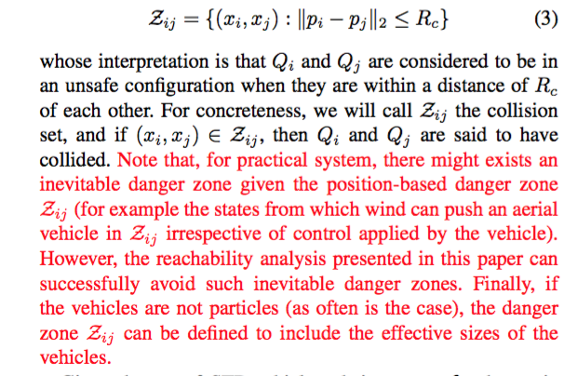

**3. Authors proposed a sequential planning method in order to make the reachable set method computing trackable with different priority when facing high dimensional problems. It makes sense in real applications that each agent has different priority. However, it may return failure when priority is not crucial or even can be ignored and the inappropriate priority is given. If the priority issue has been considered by authors, please give more details and explanation.**

This is a good point, and requires clarification on our part.

Our algorithm always returns a safe and timely feasible trajectory, as long as one exists in the absence of other vehicles. Feasibility is also independent of the chosen priority. This is because any vehicle can simply depart early enough to avoid crowded environments to arrive earlier than required. The latest time of arrival provided by our algorithm quantifies exactly how early each vehicle needs to depart given a priority ordering. Of course, practically speaking there may be situations in which a vehicle cannot depart early enough; however, this is always a concern with any trajectory planning method.

We have clarified this point near the end of Section II, and at the end of Section IV-A.

**4. Comparative studies are suggested to show the advantages of the proposed algorithm. In addition, more recent work of multi-agent (AGV, UAV, AUV, etc) is suggested to be mentioned in the introduction.**

We have added a few recent references in the introduction. Recent related work solves different problems with different assumptions, for example on vehicle dynamics. We have stated the contributions of some previous work in more detail, and clarified the contributions of our work in the introduction as well as in several subsequent sections to address the key confusing points brought up in the review.

# Reviewer: 3. Comments to the Author

**The paper presents a theorical multirobots path planning study.**

**Robustness, disturbance and adversarial are considered.**

**Study is leaded in theory with different information control policy, from centralized, vehicules' time arrival and trajectories' robustness.**

**Numerical simulations are presented with four robots in a 2D maps with two obstacles.**

**in section I :**

**The references are presented succinctly. Make one sentence per reference should help the reader to understand issues and contributions.**

**Some references should probably be removed. (see "1-5", "6:7", "8-11", "17-19", ...)**

**Some references are cited as other contributions, called "and many others" by Authors (see "23-25", "37-38", ...)**

We have revised the references in the introduction. In particular, we have removed 5 references in the introduction, and added 5 more recent and more relevant references. For some of these references, more detailed description is added to provide readers with slightly better understanding.

**in section II, III, IV, V :**

**Vehicules seems to be particules ?**

This is a very good point, and requires further clarification on our part. Even though all the simulations in the paper are presented under the assumption of particle vehicles, the proposed methodology is not limited to particles. For general vehicles, the danger zone can be defined such that it includes the *effective* size of the vehicle. We have also clarified this in the main text.



**Configuration spaces is then simplified and robustness is delegated to surrounding distance of other things.**

**time-varying reachability is formalized**

**perfect and imperfect information cases are presented with numerical simulations for four vehicules.**

**comparisons to previous works are missing**

**simulations should involve more vehicules and more obstacles**

We agree that a simulation involving more vehicles, ideally catered to a particular exciting application, would be great to have. However, we believe that our simulations adequately illustrates our proposed approach as a general theoretical framework that can be applied to various applications; adding more vehicles would not necessarily provide additional insight. For example, Figures 2, 3, 7, 9, 11 provide low-level intuition about the backward reachable sets, the underlying theoretical mechanism for trajectory planning. In the future, we will definitely explore realistic scenarios to gain application-specific insight.

**in section VI :**

**The case of an environment with a single moving obstacle is presented as intruder or adversarial vehicules.**

**The second assumption is an unrealistic condition.**

We agree with the reviewer that Assumption 2 is a relatively strong assumption. However, in general, a coarse dynamics model of the intruder can also be used for reachability. Consequently, the planning algorithm will be very conservative. We have added the following clarification in the main text.

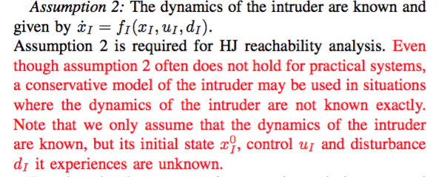

**in bibliography :**

**page number is sometimes missing**

**reference title is sometimes written with capitals (see 12, 29)**

**Out of fourty-three references, only fourteen have been published after 2010. It confirms that some references are not needed.**

We have revised the references in the introduction as well as in the bibliography. Please see our response to an earlier similar comment above.